**1) Write a program to display merit list of students using structure.**

**CODE 1 :**

// 1.Write a program to display the merit list of students using structure.

#include <stdio.h>

struct merit

{

char name[15];

int roll_no;

float mark;

}s[100], temp;

int main()

{

int n, i, j;

printf("Enter the number of student: ");

scanf("%d", &n);

printf("\n");

for (int i = 0; i < n; i++)

{

printf("Enter the name of student %d: ", i + 1);

scanf("%s", s[i].name);

printf("Enter the roll no. of student %d: ", i + 1);

scanf("%d", &s[i].roll_no);

printf("Enter the marks of student %d: ", i + 1);

scanf("%f", &s[i].mark);

printf("\n");

fflush(stdin);

}

printf("The list of students merit as below: \n");

for (i = 0; i < n; i++)

2

{

for (j = 0; j < (n - 1); j++)

{

if (s[j].mark < s[j + 1].mark)

{

temp = s[j];

s[j] = s[j + 1];

s[j + 1] = temp;

}

}

}

printf("\nNAME\t\tROLL_NO\t\tMARKS\n");

printf("-------------------------------------------------------\n");

for (i = 0; i < n; i++)

{

printf("%s\t\t%d\t\t%f\n", s[i].name, s[i].roll_no, s[i].mark);

}

return 0;

}

**OUTPUT 1 :**

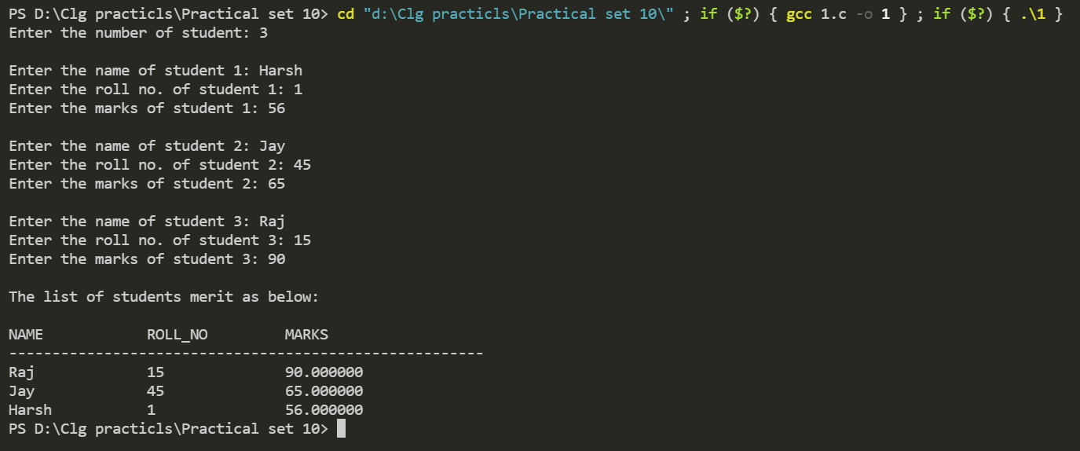

**2) Write a program which writes whole ASCII set in the file “ASC_SET”,After that program reads and prints only digits and uppercase alphabets from the file.**

**CODE 2 :**

/* 2.Write a program which writes the whole ASCII set in the file“ASC_SET”,After that program reads and prints only digits and uppercase alphabets from the file.*/

#include <stdio.h>

#include <string.h>

int main()

{

FILE *ptr;

ptr = fopen("ASC_SET.txt", "w");

char c;

int i;

for (i = 0; i < 256; i++)

{

putc(i, ptr);

}

fclose(ptr);

ptr = fopen("ASC_SET.txt", "r");

printf("\nDigits are: ");

fseek(ptr, 49, SEEK_SET);

for (int i = 0; i < 10; i++)

{

c = getc(ptr);

printf("%c ", c);

}

printf("\nCapital letters are: ");

fseek(ptr, 66, SEEK_SET);

for (int i = 0; i < 26; i++)

{

c = getc(ptr);

printf("%c ", c);

}

fclose(ptr);

return 0;

}

**OUTPUT 2 :**

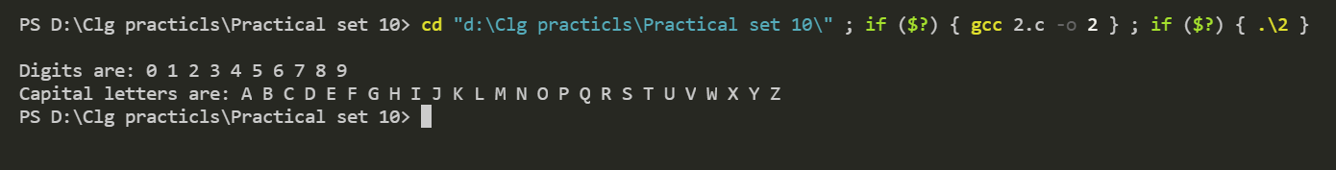

**3) Write a program to read 10 names from a file and store them in sorted order in same file.**

**CODE 3 :**

/* 3.Write a program to read 10 names from a file and store them in sorted

order in the same file.*/

#include <stdio.h>

#include <string.h>

int main()

{

FILE *ptr;

ptr = fopen("Set_10_03.txt", "w");

char name[10][20];

char temp[20];

printf("Enter the name under 20 characters.\n");

for (int i = 0; i < 10; i++)

{

scanf("%s", name[0]);

fputs(name[0], ptr);

fputc('\n', ptr);

}

fclose(ptr);

ptr = fopen("Set_10_03.txt", "r");

for (int i = 0; i < 10; i++)

{

fgets(name[i], 20, ptr);

}

for (int i = 0; i < 10; i++)

{

for (int j = 0; j < 10; j++)

{

if (strcmp(name[i], name[j]) < 0)

{

strcpy(temp, name[i]);

strcpy(name[i], name[j]);

strcpy(name[j], temp);

}

}

}

fclose(ptr);

ptr = fopen("Set_10_03.txt", "w");

for (int i = 0; i < 10; i++)

{

fputs(name[i], ptr);

}

fclose(ptr);

ptr = fopen("Set_10_03.txt", "r");

printf("\nShorted Name: \n");

for (int i = 0; i < 10; i++)

{

fgets(name[i], 20, ptr);

printf("%s", name[i]);

}

fclose(ptr);

return 0;

}

**OUTPUT 3 :**

